EMPLOYEE PAYROLL MANAGEMENT SYSTEM

Using Python and MySQL

A Project Report

Computer Science (083)

TABLE OF CONTENTS

1. Introduction | 3
2. Objectives of the Project | 3
3. Software and Hardware Requirements | 4
4. Database Design | 5
5. Theory / Working of the Project | 6
6. Source Code | 7
7. Sample Output with Screenshots | 9
8. Limitations of the Project | 14
9. Future Scope | 14
10. Conclusion | 15
11. Bibliography | 15

1. INTRODUCTION

Managing employee salary records manually is difficult and time-consuming. Errors in salary calculation may lead to dissatisfaction among employees. To overcome these problems, an Employee Payroll Management System using Python and MySQL database connectivity has been developed.

This project stores employee details permanently in a database and calculates salary efficiently using a computerized system. The system provides a user-friendly menu-driven interface to perform various operations on employee records.

2. OBJECTIVES OF THE PROJECT

The objectives of this project are:
- To understand Python–MySQL database connectivity
- To store employee data permanently in a database
- To perform insert, update, delete, and display operations
- To calculate employee salary automatically
- To develop a menu-driven database application

3. SOFTWARE AND HARDWARE REQUIREMENTS

Software Requirements
- Python 3.x
- MySQL Server
- MySQL Connector for Python
- Python IDE (IDLE / VS Code)

Hardware Requirements
- Computer / Laptop
- Minimum 2 GB RAM
- Keyboard and Mouse

4. DATABASE DESIGN

Database Name:
company

Table Name:
employee

Table Structure:

Field Name | Data Type
emp_id | INT (Primary Key)
emp_name | VARCHAR(30)
basic_salary | INT
allowance | INT
total_salary | INT

SQL Command to Create Database & Table:

CREATE DATABASE company;
USE company;
CREATE TABLE employee (
emp_id INT PRIMARY KEY,
emp_name VARCHAR(30),
basic_salary INT,
allowance INT,
total_salary INT
);

5. THEORY / WORKING OF THE PROJECT

This project is a menu-driven application that connects Python with MySQL using the mysql.connector library. The system provides a simple console-based interface for managing employee records.

The system allows the user to:
- Add employee records - Insert new employee data with automatic salary calculation
- Display employee records - View all stored employee information
- Update salary details - Modify basic salary and allowance for existing employees
- Delete employee records - Remove employee records from the database
- Exit the program - Safely close the application

All employee data is stored permanently in the MySQL database, ensuring data persistence across sessions. The total salary is automatically calculated as the sum of basic salary and allowance.

6. SOURCE CODE (PYTHON + MYSQL CONNECTIVITY)

Python Source Code:

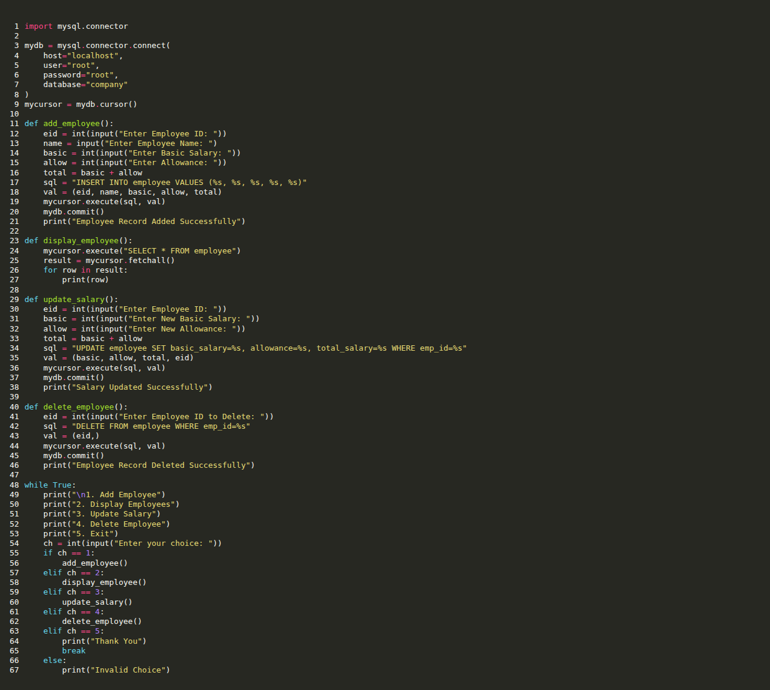

7. SAMPLE OUTPUT WITH SCREENSHOTS

Output Screen 1: Main Menu


Output Screen 2: Add Employee Records
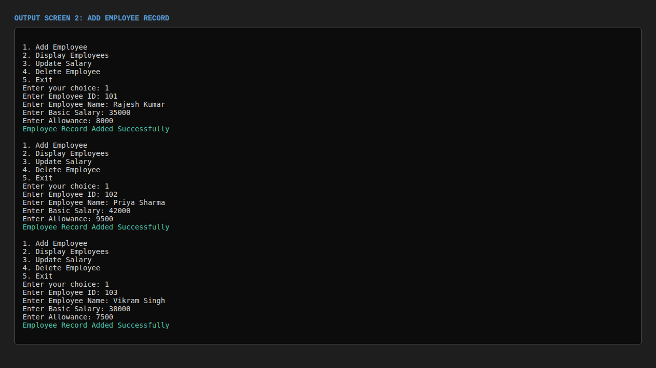

Output Screen 3: Display Employee Records
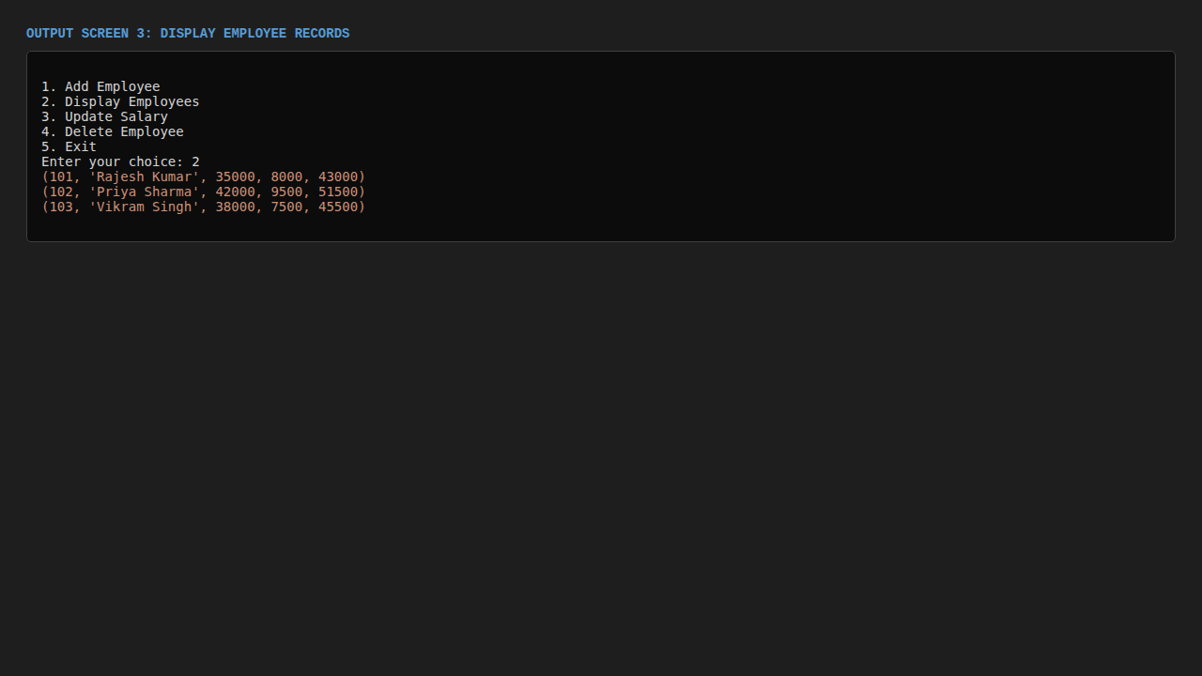

Output Screen 4: Update Employee Salary
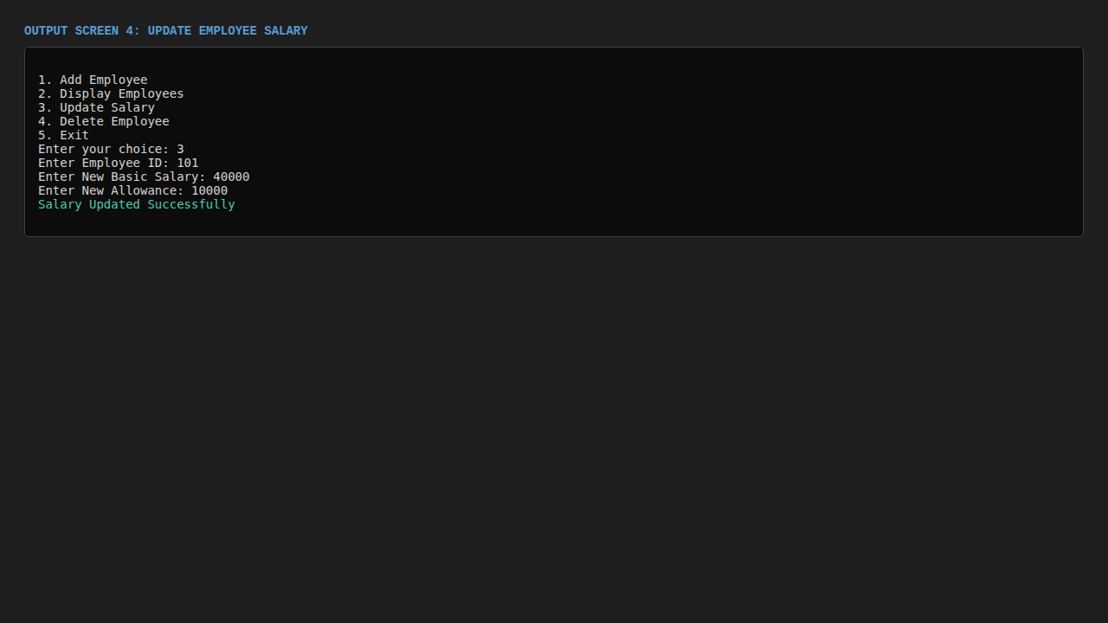

Output Screen 5: Display After Salary Update
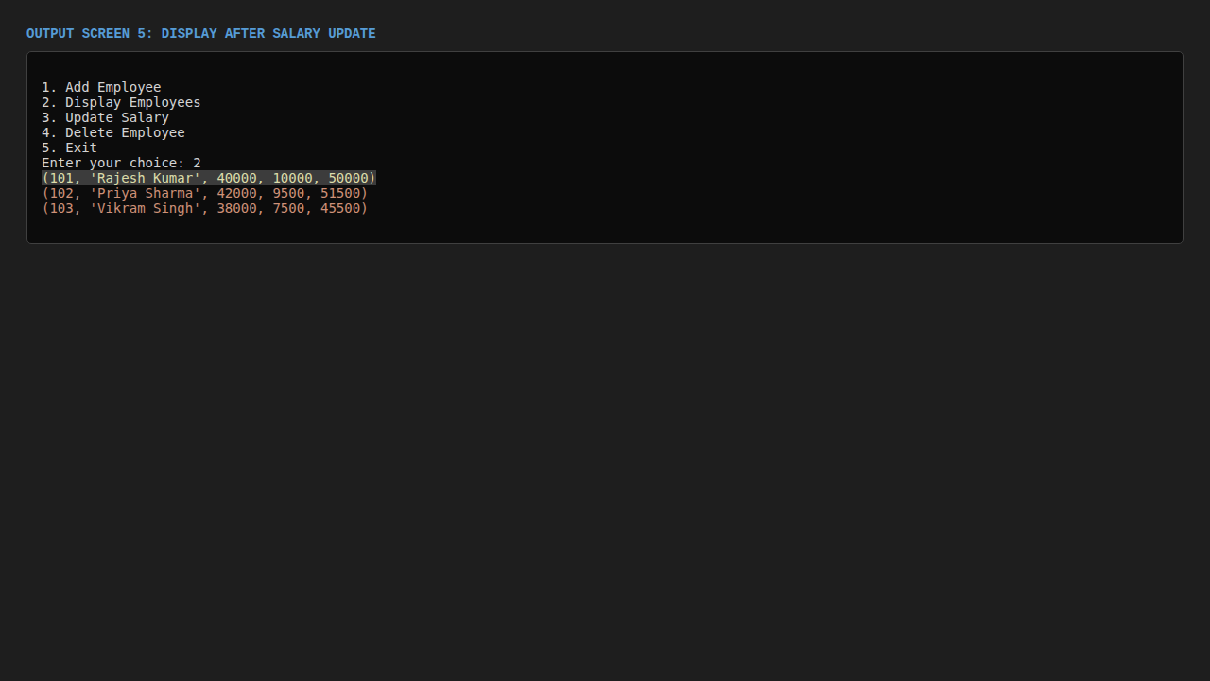

Output Screen 6: Delete Employee Record
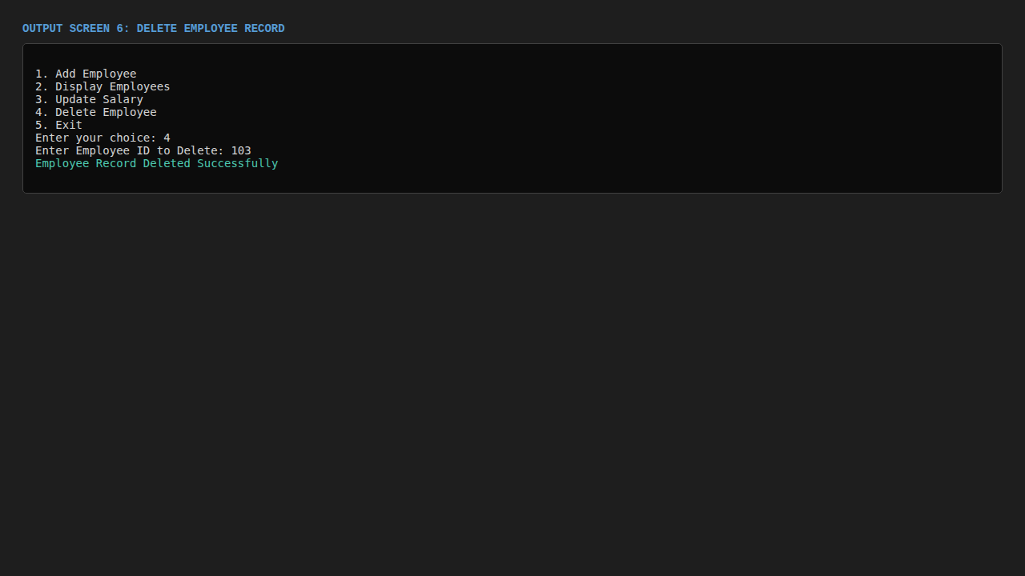

Output Screen 7: Final Display
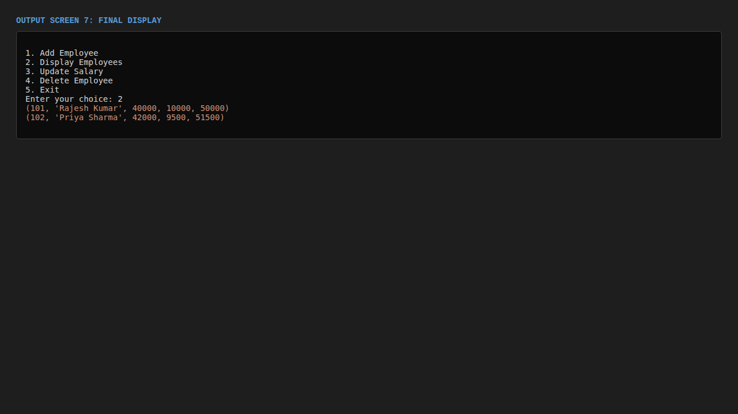

Output Screen 8: Exit Program
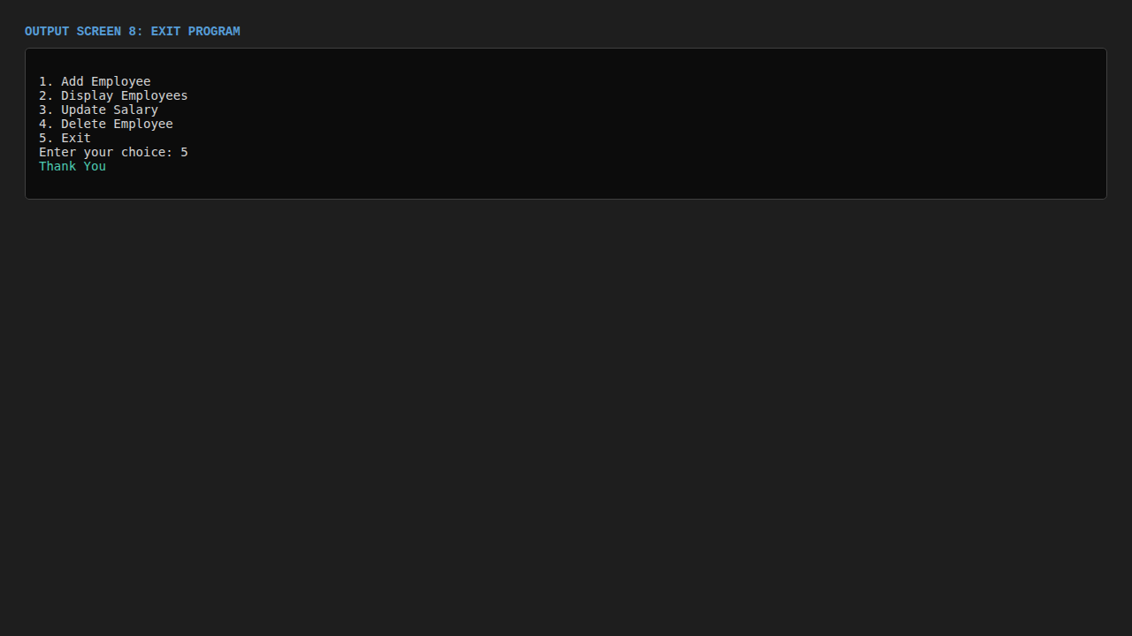

8. LIMITATIONS OF THE PROJECT

- No login authentication or user security
- No graphical user interface (console-based only)
- Single-user system - cannot handle concurrent access
- No input validation for data entry
- No backup and recovery mechanism

9. FUTURE SCOPE

- Adding password security and user authentication
- Graphical User Interface (GUI) using Tkinter or PyQt
- Tax and deduction calculation features
- Report generation in PDF/Excel format
- Multi-user support with role-based access
- Cloud database integration for remote access

10. CONCLUSION

The Employee Payroll Management System effectively demonstrates how Python and MySQL can be used together to manage employee records efficiently. This project has provided valuable hands-on experience in:

- Database connectivity using Python
- CRUD operations (Create, Read, Update, Delete)
- Menu-driven application development
- SQL query execution from Python
- Real-world application development

This project enhanced understanding of database connectivity and demonstrates the practical application of programming concepts in solving real-world problems.

11. BIBLIOGRAPHY

- NCERT Computer Science Class XII Textbook
- Python Documentation - https://docs.python.org/
- MySQL Documentation - https://dev.mysql.com/doc/
- MySQL Connector Python Documentation
- GeeksforGeeks - Python MySQL Connectivity

